**Programming Fundamentals 2**

Danny O’Leary, Daniel Ivers, Jamie Doyle, Adam O’Reilly

2nd – 8th March

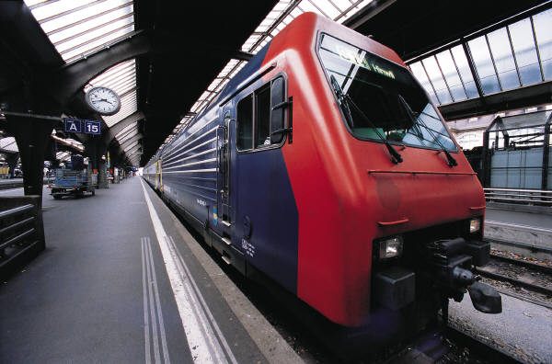

Week 1 of PBL Assignment - Timesheet

**What needed to be done?**

1. Team roles had to be decided
2. Assign a day and time for meetings
3. Generate ideas on how to tackle assignment
4. Come up with possible classes needed
5. Research possible GUI’s
6. **Team Roles**

* Daniel was chosen to be the main record keeper. But other team member agreed to take this role from time to time
* Jamie was chosen to be the first discussion leader at the first meeting, and this would alternate afterwards.

1. **Meeting allocation**

* We decided that 9:15 on Wednesday mornings would be our official meeting day. But if we could fit in spare time, we would use it to meet up and discuss the assignment.

1. **Ideas on Assignment**

* We decided to work on this straight away and come up with as many early possible ideas that we could think of. Adam came up with really useful ideas on how to use the random number generators effectively.

1. **Classes needed**

* We all pitched in on the possible classes that we needed and what was potentially needed inside each one. We also agreed on a suitable naming convention for each class.

1. **GUI’s**

* We all took to the internet, to see if we could implement a GUI into the assignment, research didn’t go well as it looked complicated and out of our time frame. We all agreed to get the bulk of the assignment out of the way first, and if there was time left near the deadline we would see if we could add one in.